 | 12.1.11 Editors - Geometry Node Editor - Header - Add Menu - Attribute
Table of content
Detailed table of content 1
Add menu 3
Attribute Statistics 3
Domain Size 4
Blur Attribute 5
Capture Attribute 6
Remove Named Attribute 7
Store Named Attribute 7

Detailed table of content
Detailed table of content
Detailed table of content 1
Add menu 3
Attribute Statistics 3
Inputs 3
Geometry 3
Selection 3
Attribute 3
Properties 3
Domain Type 3
Outputs 3
Mean 4
Median 4
Sum 4
Min 4
Max 4
Range 4
Standard Derivation 4
Variance 4
Domain Size 4
Input 4
Geometry 4
Properties 4
Component 4
Output 5
With type mesh 5
Point Count 5
Edge Count 5
Face Count 5
Face Corner Count 5
With type Point Cloud 5
Point Count 5
With type Curve 5
Point Count 5
Spline Count 5
With type Instances 5
Instances count 5
Blur Attribute 5
Inputs 5
Value 5
Iterations 5
Properties 6
Outputs 6
Value 6
Capture Attribute 6
Inputs 6
Geometry 6
Empty socket 6
Outputs 7
Geometry 7
Attribute 7
Remove Named Attribute 7
Input 7
Geometry 7
Pattern Mode 7
Name 7
Outputs 7
Geometry 7
Store Named Attribute 7
Input 7
Geometry 7
Selection 7
Name 7
Value 8
Properties 8
Data Type 8
Domain 8
Outputs 8
Geometry 8

Add menu

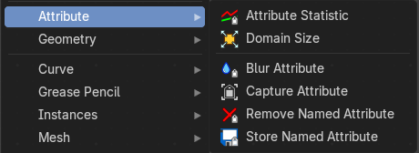
The Attribute menu contains the attribute nodes. These nodes allows you to work with object attributes.

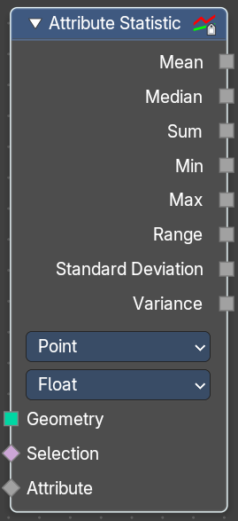
Attribute Statistics
Retreive statistic values from the input mesh.

Inputs

Geometry
Standard geometry input.

Selection
A selection of the geometry input.

Attribute
Attribute to get the statistics from.

Properties

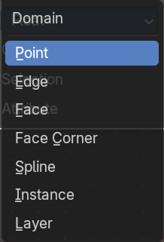
Domain Type
From which domain to retreive the data.

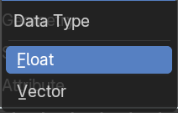
Data Type
What data type to use.
Float will output a single floating point value.
Vector will outupt a vector 3 with floating point values.

Outputs
Outputs the statistics for the different types.

Mean
The average value of all data.

Median
The median value of all data.

Sum
The sum value of all data.

Min
The min value of all data.

Max
The max value of all data.

Range
The difference between the max and min value.

Standard Derivation
How much values differ from the mean. A low standard deviation indicates that the values are grouped tightly together at the mean. A high standard deviation indicates that the values are spread out over a large range.

Variance
The variance of all data, defined as the square of the standard deviation.

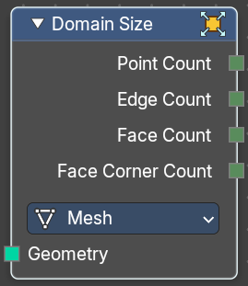
Domain Size
The Domain Size node has a single geometry input and a selection for the component type. And outputs containing single values for the related domains are shown, based on this chosen component.

Input

Geometry
Geometry input.

Properties

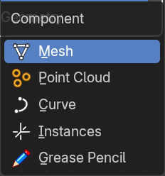
Component
What component to calculate.

Output

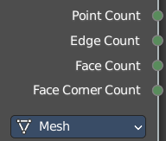
With type mesh

Point Count
The point count of the mesh.

Edge Count
The edge count of the mesh.

Face Count
The face count of the mesh.

Face Corner Count
The face corner count of the mesh.

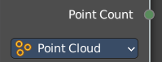
With type Point Cloud

Point Count
The point count of the point cloud.

With type Curve

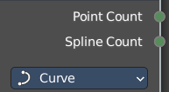
Point Count
The point count of the curve.

Spline Count
The number of splines in the curve.

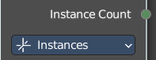
With type Instances

Instances count
How many instances the input geometry has.

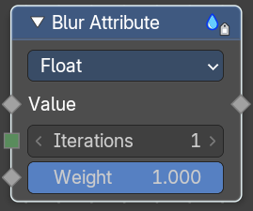
Blur Attribute
The Blur Attribute mixes values of neighbour elements.

Inputs

Value
Name of the attribute that is used as input. It should be a float attribute with values between zero and one.

Iterations
How many times to blur the values for all elements.
Weight
Relative mix weigth of neighbouring elements.

Properties
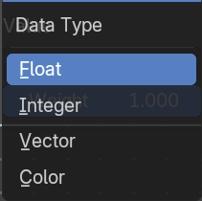
Data Type
What data type to use.

Outputs

Value
The output value.

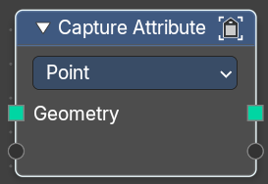
Capture Attribute
The Capture Attribute node stores the result of a field on a geometry, and outputs the data as a node socket so it can be used by other nodes.
The result is stored on the geometry just like a regular attribute with a name. But instead of referencing it with a name, it is retrieved whenever the socket is connected to the input of a node. Later on when evaluating the node tree, the attribute will be removed automatically if it is no longer used.

Inputs

Geometry
Standard geometry input.

Empty socket
Connect a node to get its attribute. Note that adding a connection creates a new empty socket. Note also that further input and output settings depends of the input socket. For a position node you will get a vector numberfield. For a color node a color output when you disconnect the former connected socket types.
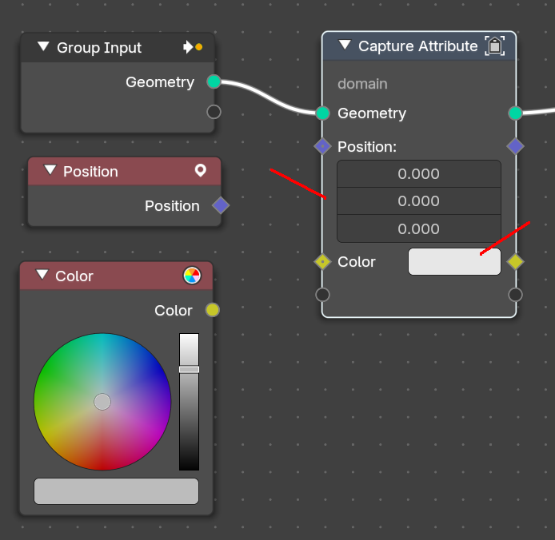
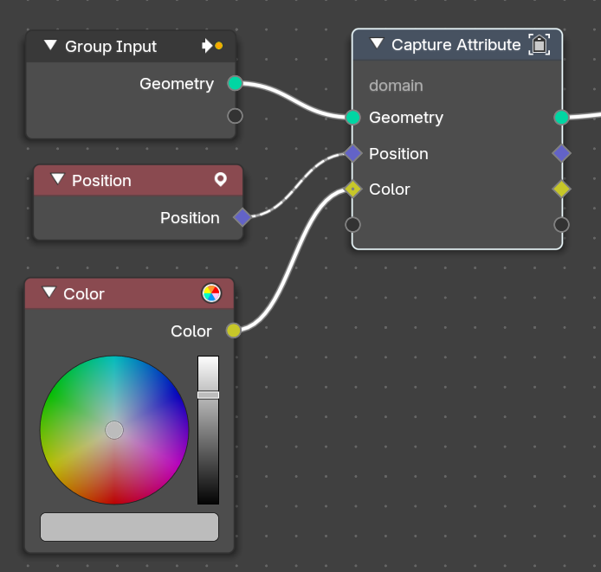

Outputs

Geometry
Standard geometry output.

Attribute
Attribute output.

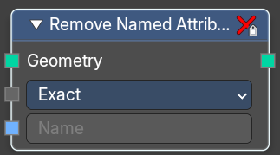
Remove Named Attribute

Input

Geometry
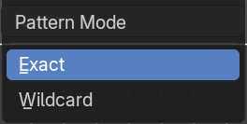
Geometry input.

Pattern Mode
How to choose the attribute to remove.

Name
The attribute name that you want to remove.

Outputs

Geometry
The output geometry.

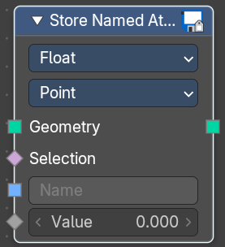
Store Named Attribute
Puts the results of a field in a named attribute.

Input

Geometry
Geometry input.

Selection
Selection input.

Name
The attribute name that you want to store.

Value
The value that is connected with the stored attribute.

Properties

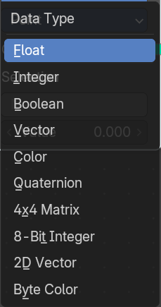
Data Type
The type for the source and result data.

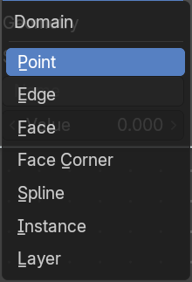
Domain
What element to use.

Outputs

Geometry
The output geometry.

